**Lesson 2: Activities and intents**

2.1: Activities and intents

**Contents:**

* [Introduction](https://google-developer-training.github.io/android-developer-fundamentals-course-concepts-v2/unit-1-get-started/lesson-2-activities-and-intents/2-1-c-activities-and-intents/2-1-c-activities-and-intents.html" \l "chapterstart)
* [About Activity](https://google-developer-training.github.io/android-developer-fundamentals-course-concepts-v2/unit-1-get-started/lesson-2-activities-and-intents/2-1-c-activities-and-intents/2-1-c-activities-and-intents.html" \l "aboutactivities)
* [Creating an Activity](https://google-developer-training.github.io/android-developer-fundamentals-course-concepts-v2/unit-1-get-started/lesson-2-activities-and-intents/2-1-c-activities-and-intents/2-1-c-activities-and-intents.html#creatingactivities)
* [About Intent](https://google-developer-training.github.io/android-developer-fundamentals-course-concepts-v2/unit-1-get-started/lesson-2-activities-and-intents/2-1-c-activities-and-intents/2-1-c-activities-and-intents.html#aboutintents)
* [Starting an Activity with an explicit Intent](https://google-developer-training.github.io/android-developer-fundamentals-course-concepts-v2/unit-1-get-started/lesson-2-activities-and-intents/2-1-c-activities-and-intents/2-1-c-activities-and-intents.html#startingactivitywithexplicitintent)
* [Passing data from one Activity to another](https://google-developer-training.github.io/android-developer-fundamentals-course-concepts-v2/unit-1-get-started/lesson-2-activities-and-intents/2-1-c-activities-and-intents/2-1-c-activities-and-intents.html#passingdatabetweenactivities)
* [Getting data back from an Activity](https://google-developer-training.github.io/android-developer-fundamentals-course-concepts-v2/unit-1-get-started/lesson-2-activities-and-intents/2-1-c-activities-and-intents/2-1-c-activities-and-intents.html#gettingdatabackfromactivity)
* [Activity navigation](https://google-developer-training.github.io/android-developer-fundamentals-course-concepts-v2/unit-1-get-started/lesson-2-activities-and-intents/2-1-c-activities-and-intents/2-1-c-activities-and-intents.html#activitynavigation)
* [Related practical](https://google-developer-training.github.io/android-developer-fundamentals-course-concepts-v2/unit-1-get-started/lesson-2-activities-and-intents/2-1-c-activities-and-intents/2-1-c-activities-and-intents.html#relatedpractical)
* [Learn more](https://google-developer-training.github.io/android-developer-fundamentals-course-concepts-v2/unit-1-get-started/lesson-2-activities-and-intents/2-1-c-activities-and-intents/2-1-c-activities-and-intents.html#learnmore)

Introduction

In this chapter you learn about the [Activity](https://developer.android.com/reference/android/app/Activity.html) class, the major building block of your app's user interface (UI). You also learn about using an [Intent](https://developer.android.com/reference/android/content/Intent.html) to communicate from one activity to another.

About activities

An *activity* represents a single screen in your app with an interface the user can interact with. For example, an email app might have one activity that shows a list of new emails, another activity to compose an email, and another activity for reading individual messages. Your app is probably a collection of activities that you create yourself, or that you reuse from other apps.

Although the activities in your app work with each other to form a cohesive user experience, each activity is independent of the others. This enables your app to start an activity in another app, and it enables other apps to start activities in your app (if your app allows this). For example, a messaging app could start an activity in a camera app to take a picture, then start an activity in an email app to let the user share the picture in email.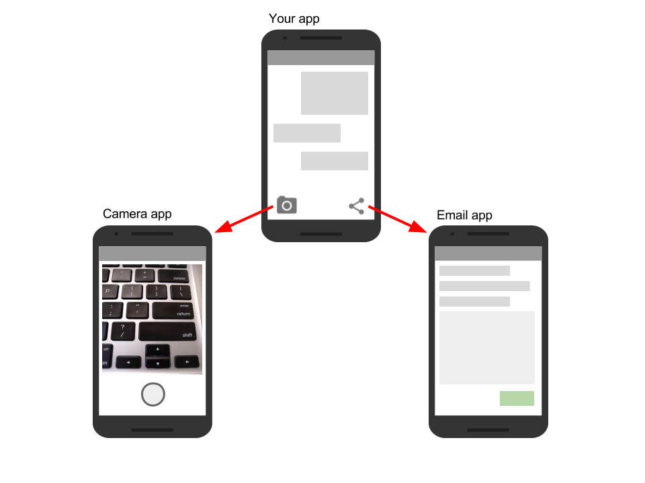

Typically, one Activity in an app is specified as the "main" activity, for example MainActivity. The user sees the main activity when they launch the app for the first time. Each activity can start other activities to perform different actions.

Each time a new activity starts, the previous activity is stopped, but the system preserves the activity in a stack (the "back stack"). When the user is done with the current activity and presses the Back button, the activity is popped from the stack and destroyed, and the previous activity resumes.

When an activity is stopped because a new activity starts, the first activity is notified by way of the activity lifecycle callback methods. The [*activity lifecycle*](https://developer.android.com/guide/components/activities/activity-lifecycle.html) is the set of states an Activity can be in: when the activity is first created, when it's stopped or resumed, and when the system destroys it. You learn more about the activity lifecycle in a later chapter.

Creating an Activity

To implement an [Activity](https://developer.android.com/reference/android/app/Activity.html) in your app, do the following:

* Create an Activity Java class.
* Implement a basic UI for the Activity in an XML layout file.
* Declare the new Activity in the AndroidManifest.xml file.

When you create a new project for your app, or add a new Activity to your app by choosing **File > New > Activity**, the template automatically performs the steps listed above.

Create the Activity

When you create a new project in Android Studio and choose the **Backwards Compatibility (AppCompat)** option, the MainActivity is, by default, a subclass of the [AppCompatActivity](https://developer.android.com/reference/android/support/v7/app/AppCompatActivity.html) class. The AppCompatActivity class lets you use up-to-date Android app features such as the app bar and Material Design, while still enabling your app to be compatible with devices running older versions of Android.

Here is a skeleton subclass of AppCompatActivity:

public class MainActivity extends AppCompatActivity {

@Override

protected void onCreate(Bundle savedInstanceState) {

super.onCreate(savedInstanceState);

setContentView(R.layout.activity_main);

}

}

The first task for you in your Activity subclass is to implement the standard Activity lifecycle callback methods (such as [onCreate()](https://developer.android.com/reference/android/app/Activity.html#onCreate(android.os.Bundle))) to handle the state changes for your Activity. These state changes include things such as when the Activity is created, stopped, resumed, or destroyed. You learn more about the Activity lifecycle and lifecycle callbacks in a different chapter.

The one required callback your app must implement is the [onCreate()](https://developer.android.com/reference/android/app/Activity.html#onCreate(android.os.Bundle)) method. The system calls this method when it creates your Activity, and all the essential components of your Activity should be initialized here. Most importantly, the onCreate() method calls [setContentView()](https://developer.android.com/reference/android/app/Activity.html#setContentView(int)) to create the primary layout for the Activity.

You typically define the UI for your Activity in one or more XML layout files. When the setContentView() method is called with the path to a layout file, the system creates all the initial views from the specified layout and adds them to your Activity. This is often referred to as *inflating* the layout.

You may often also want to implement the [onPause()](https://developer.android.com/reference/android/app/Activity.html#onPause()) method in your Activity. The system calls this method as the first indication that the user is leaving your Activity (though it does not always mean that the Activity is being destroyed). This is usually where you should commit any changes that should be persisted beyond the current user session (because the user might not come back). You learn more about onPause() and all the other lifecycle callbacks in a later chapter.

In addition to lifecycle callbacks, you may also implement methods in your Activity to handle other behavior such as user input or button clicks.

Implement the activity's UI

The UI for an activity is provided by a hierarchy of View elements, which controls a particular space within the activity window and can respond to user interaction.

The most common way to define a UI using View elements is with an XML layout file stored as part of your app's resources. Defining your layout in XML enables you to maintain the design of your UI separately from the source code that defines the activity behavior.

You can also create new View elements directly in your activity code by inserting new View objects into a ViewGroup, and then passing the root ViewGroup to setContentView(). After your layout has been inflated—regardless of its source—you can add more View elements anywhere in the View hierarchy.

Declare the Activity in AndroidManifest.xml

Each Activity in your app must be declared in the AndroidManifest.xml file with the <activity> element, inside the <application> section. When you create a new project or add a new Activity to your project in Android Studio, the AndroidManifest.xml file is created or updated to include skeleton declarations for each Activity. Here's the declaration for MainActivity:

<activity android:name=".MainActivity" >

<intent-filter>

<action android:name="android.intent.action.MAIN" />

<category android:name="android.intent.category.LAUNCHER" />

</intent-filter>

</activity>

The <activity> element includes a number of attributes to define properties of the Activity such as its label, icon, or theme. The only required attribute is android:name, which specifies the class name for the Activity (such as MainActivity). See the [<activity>](https://developer.android.com/guide/topics/manifest/activity-element.html) element reference for more information on Activity declarations.

The <activity> element can also include declarations for Intent filters. The Intent filters specify the kind of Intent your Activity will accept.

<intent-filter>

<action android:name="android.intent.action.MAIN" />

<category android:name="android.intent.category.LAUNCHER" />

</intent-filter>

Intent filters must include at least one <action> element, and can also include a <category> and optional <data>. The MainActivity for your app needs an Intent filter that defines the "main" action and the "launcher" category so that the system can launch your app. Android Studio creates this Intent filter for the MainActivity in your project.

The <action> element specifies that this is the "main" entry point to the app. The <category> element specifies that this Activity should be listed in the system's app launcher (to allow users to launch this Activity).

Each Activity in your app can also declare Intent filters, but only your MainActivity should include the "main" action. You learn more about how to use an implicit Intent and Intent filters in a later section.

Add another Activity to your project

The MainActivity for your app and its associated layout file is supplied by an Activity template in Android Studio such as Empty Activity or Basic Activity. You can add a new Activity to your project by choosing **File > New > Activity**. Choose the Activity template you want to use, or open the Gallery to see all the available templates.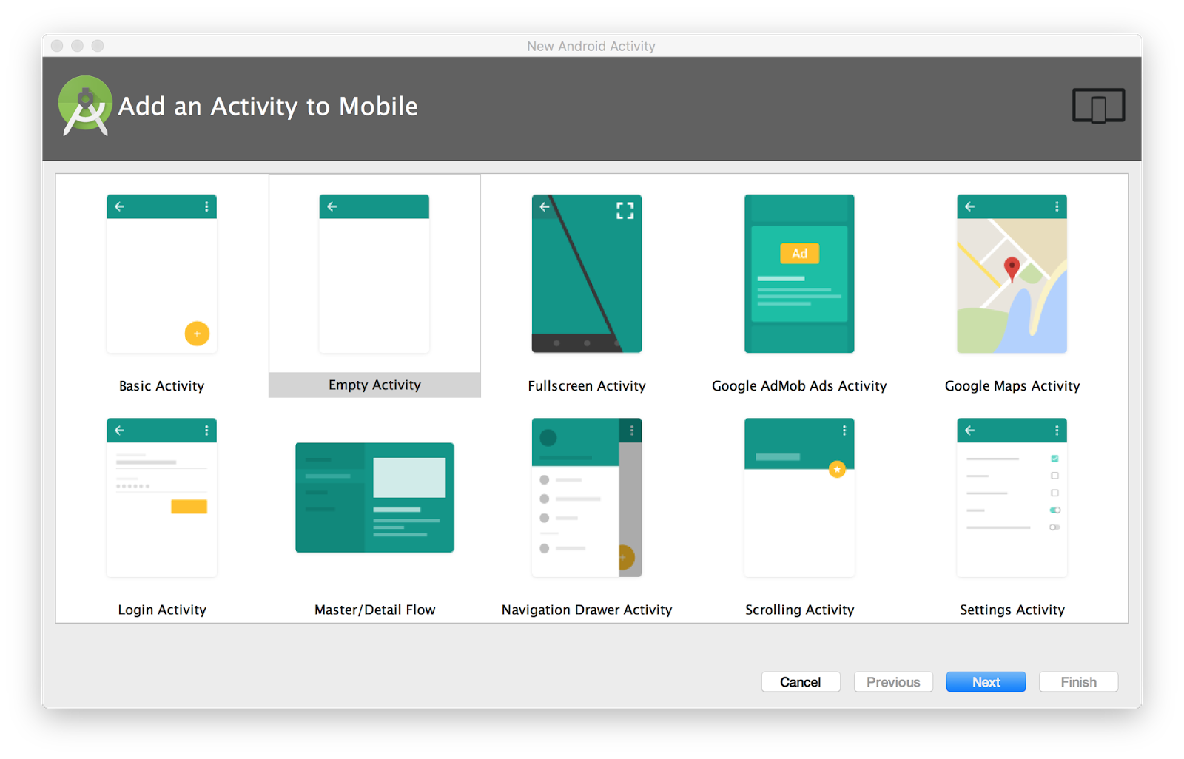

When you choose an Activity template, you see the same set of screens for creating the new activity that you did when you created the project. Android Studio provides three things for each new activity in your app:

* A Java file for the new Activity with a skeleton class definition and onCreate() method. The new Activity, like MainActivity, is a subclass of AppCompatActivity.
* An XML file containing the layout for the new activity. Note that the setContentView() method in the Activity class inflates this new layout.
* An additional <activity> element in the AndroidManifest.xml file that specifies the new activity. The second Activity definition does not include any Intent filters. If you plan to use this activity only within your app (and not enable that activity to be started by any other app), you do not need to add filters.

About intents

Each activity is started or activated with an [Intent](https://developer.android.com/reference/android/content/Intent.html), which is a message object that makes a request to the Android runtime to start an activity or other app component in your app or in some other app.

When your app is first started from the device home screen, the Android runtime sends an Intent to your app to start your app's main activity (the one defined with the MAIN action and the LAUNCHER category in the AndroidManifest.xml file). To start another activity in your app, or to request that some other activity available on the device perform an action, you build your own intent and call the startActivity() method to send the intent.

In addition to starting an activity, an intent can also be used to pass data between one activity and another. When you create an intent to start a new activity, you can include information about the data you want that new activity to operate on. So, for example, an email Activity that displays a list of messages can send an Intent to the Activity that displays that message. The display activity needs data about the message to display, and you can include that data in the intent.

In this chapter you learn about using intents with activities, but intents can also be used to start services or broadcast receivers. You learn how to use those app components in another practical.

Intent types

Intents can be *explicit* or *implicit*:

* *Explicit intent:*You specify the receiving activity (or other component) using the activity's fully qualified class name. You use explicit intents to start components in your own app (for example, to move between screens in the UI), because you already know the package and class name of that component.
* *Implicit intent:*You do *not* specify a specific activity or other component to receive the intent. Instead, you declare a general action to perform, and the Android system matches your request to an activity or other component that can handle the requested action. You learn more about using implicit intents in another practical.

Intent objects and fields

For an explicit Intent, the key fields include the following:

* The Activity *class* (for an explicit Intent). This is the class name of the Activity or other component that should receive the Intent; for example, com.example.SampleActivity.class. Use the Intent constructor or the setComponent(), setComponentName(), or setClassName() methods to specify the class.
* The Intent *data.* The Intent data field contains a reference to the data you want the receiving Activity to operate on as a Uri object.
* Intent *extras.*These are key-value pairs that carry information the receiving Activity requires to accomplish the requested action.
* Intent [*flags*](https://developer.android.com/reference/android/content/Intent.html#setFlags(int))*.*These are additional bits of metadata, defined by the Intent class. The flags may instruct the Android system how to launch an Activity or how to treat it after it's launched.

For an implicit Intent, you may need to also define the Intent action and category. You learn more about Intent actions and categories in another chapter.

Starting an Activity with an explicit Intent

To start a specific Activity from another Activity, use an explicit Intent and the [startActivity()](https://developer.android.com/reference/android/app/Activity.html#startActivity(android.content.Intent,%20android.os.Bundle)) method. An explicit Intent includes the fully qualified class name for the Activity or other component in the Intent object. All the other Intent fields are optional, and null by default.

For example, if you want to start the ShowMessageActivity to show a specific message in an email app, use code like this:

Intent messageIntent = new Intent(this, ShowMessageActivity.class);

startActivity(messageIntent);

The intent constructor takes two arguments for an explicit Intent:

* An application context. In this example, the Activity class provides the context (this).
* The specific component to start (ShowMessageActivity.class).

Use the startActivity() method with the new Intent object as the only argument. The startActivity() method sends the Intent to the Android system, which launches the ShowMessageActivity class on behalf of your app. The new Activity appears on the screen, and the originating Activity is paused.

The started Activity remains on the screen until the user taps the Back button on the device, at which time that Activity closes and is reclaimed by the system, and the originating Activity is resumed. You can also manually close the started Activity in response to a user action (such as a Button click) with the [finish()](https://developer.android.com/reference/android/app/Activity.html#finish()) method:

public void closeActivity (View view) {

finish();

}

Passing data from one Activity to another

In addition to simply starting one Activity from another Activity, you also use an Intent to *pass information* from one Activity to another. The Intent object you use to start an Activity can include Intent *data* (the URI of an object to act on), or Intent *extras*, which are bits of additional data the Activity might need.

In the first (sending) Activity, you:

1. Create the Intent object.
2. Put data or extras into that Intent.
3. Start the new Activity with startActivity().

In the second (receiving) Activity, you:

1. Get the Intent object the Activity was started with.
2. Retrieve the data or extras from the Intent object.

When to use Intent data or Intent extras

You can use either Intent data or Intent extras to pass data from one Activity to another. There are several key differences between data and extras that determine which you should use.

The Intent *data* can hold only one piece of information: a URI representing the location of the data you want to operate on. That URI could be a web page URL (http://), a telephone number (tel://), a geographic location (geo://) or any other custom URI you define.

Use the Intent data field:

* When you only have one piece of information you need to send to the started Activity.
* When that information is a data location that can be represented by a URI.

Intent *extras* are for any other arbitrary data you want to pass to the started Activity. Intent extras are stored in a [Bundle](https://developer.android.com/reference/android/os/Bundle.html) object as key and value pairs. A Bundle is a map, optimized for Android, in which a key is a string, and a value can be any primitive or object type (objects must implement the [Parcelable](https://developer.android.com/reference/android/os/Parcelable.html) interface). To put data into the Intent extras you can use any of the [Intent](https://developer.android.com/reference/android/content/Intent.html) class putExtra() methods, or create your own Bundle and put it into the Intent with [putExtras()](https://developer.android.com/reference/android/content/Intent.html#putExtras(android.os.Bundle)).

Use the Intent extras:

* If you want to pass more than one piece of information to the started Activity.
* If any of the information you want to pass is not expressible by a URI.

Intent data and extras are not exclusive; you can use data for a URI and extras for any additional information the started Activity needs to process the data in that URI.

Add data to the Intent

To add data to an explicit Intent from the originating Activity, create the Intent object as you did before:

Intent messageIntent = new Intent(this, ShowMessageActivity.class);

Use the [setData()](https://developer.android.com/reference/android/content/Intent.html#setData(android.net.Uri)) method with a Uri object to add that URI to the Intent. Some examples of using setData() with URIs:

// A web page URL

messageIntent.setData(Uri.parse("http://www.google.com"));

// a Sample file URI

messageIntent.setData(Uri.fromFile(new File("/sdcard/sample.jpg")));

// A sample content: URI for your app's data model

messageIntent.setData(Uri.parse("content://mysample.provider/data"));

// Custom URI

messageIntent.setData(Uri.parse("custom:" + dataID + buttonId));

Keep in mind that the data field can only contain a single URI; if you call setData() multiple times only the last value is used. Use Intent extras to include additional information (including URIs.)

After you've added the data, you can start the Activity with the Intent as usual:

startActivity(messageIntent);

Add extras to the Intent

To add Intent extras to an explicit Intent from the originating Activity:

1. Determine the keys to use for the information you want to put into the extras, or define your own. Each piece of information needs its own unique key.
2. Use the putExtra() methods to add your key/value pairs to the Intent extras. Optionally you can create a [Bundle](https://developer.android.com/reference/android/os/Bundle.html) object, add your data to the Bundle, and then add the Bundle to the Intent.

The [Intent](https://developer.android.com/reference/android/content/Intent.html) class includes extra keys you can use, defined as constants that begin with the word EXTRA_. For example, you could use [Intent.EXTRA_EMAIL](https://developer.android.com/reference/android/content/Intent.html#EXTRA_EMAIL) to indicate an array of email addresses (as strings), or [Intent.EXTRA_REFERRER](https://developer.android.com/reference/android/content/Intent.html#EXTRA_REFERRER) to specify information about the originating Activity that sent the Intent.

You can also define your own Intent extra keys. Conventionally you define Intent extra keys as static variables with names that begin with EXTRA_. To guarantee that the key is unique, the string value for the key itself should be prefixed with your app's fully qualified class name. For example:

public final static String EXTRA_MESSAGE =

"com.example.mysampleapp.MESSAGE";

public final static String EXTRA_POSITION_X = "com.example.mysampleapp.X";

public final static String EXTRA_POSITION_Y = "com.example.mysampleapp.Y";

Create an Intent object (if one does not already exist):

Intent messageIntent = new Intent(this, ShowMessageActivity.class);

Use a putExtra() method with a key to put data into the Intent extras. The Intent class defines many putExtra() methods for different kinds of data:

messageIntent.putExtra(EXTRA_MESSAGE, "this is my message");

messageIntent.putExtra(EXTRA_POSITION_X, 100);

messageIntent.putExtra(EXTRA_POSITION_Y, 500);

Alternately, you can create a new Bundle and populate that Bundle with your Intent extras. [Bundle](https://developer.android.com/reference/android/os/Bundle.html) defines many "put" methods for different kinds of primitive data as well as objects that implement Android's [Parcelable](https://developer.android.com/reference/android/os/Parcelable.html) interface or Java's [Serializable](https://developer.android.com/reference/java/io/Serializable.html).

Bundle extras = new Bundle();

extras.putString(EXTRA_MESSAGE, "this is my message");

extras.putInt(EXTRA_POSITION_X, 100);

extras.putInt(EXTRA_POSITION_Y, 500);

After you've populated the Bundle, add it to the Intent with the [putExtras()](https://developer.android.com/reference/android/content/Intent.html#putExtras(android.os.Bundle)) method (note the "s" in Extras):

messageIntent.putExtras(extras);

Start the Activity with the Intent as usual:

startActivity(messageIntent);

Retrieve the data from the Intent in the started Activity

When you start an Activity with an Intent, the started Activity has access to the Intent and the data it contains.

To retrieve the Intent the Activity (or other component) was started with, use the [getIntent()](https://developer.android.com/reference/android/app/Activity.html#getIntent()) method:

Intent intent = getIntent();

Use [getData()](https://developer.android.com/reference/android/content/Intent.html#getData()) to get the URI from that Intent:

Uri locationUri = intent.getData();

To get the extras out of the Intent, you need to know the keys for the key/value pairs. You can use the standard Intent extras if you used those, or you can use the keys you defined in the originating Activity (if they were defined as public.)

Use one of the getExtra() methods to extract extra data out of the Intent object:

String message = intent.getStringExtra(MainActivity.EXTRA_MESSAGE);

int positionX = intent.getIntExtra(MainActivity.EXTRA_POSITION_X);

int positionY = intent.getIntExtra(MainActivity.EXTRA_POSITION_Y);

Or you can get the entire extras Bundle from the Intent and extract the values with the various [Bundle](https://developer.android.com/reference/android/os/Bundle.html) methods:

Bundle extras = intent.getExtras();

String message = extras.getString(MainActivity.EXTRA_MESSAGE);

Getting data back from an Activity

When you start an Activity with an Intent, the originating Activity is paused, and the new Activity remains on the screen until the user clicks the Back button, or you call the finish() method in a click handler or other function that ends the user's involvement with this Activity.

Sometimes when you send data to an Activity with an Intent, you would like to also get data back from that Intent. For example, you might start a photo gallery Activity that lets the user pick a photo. In this case your original Activity needs to receive information about the photo the user chose back from the launched Activity.

To launch a new Activity and get a result back, do the following steps in your originating Activity:

1. Instead of launching the Activity with startActivity(), call [startActivityForResult()](https://developer.android.com/reference/android/app/Activity.html#startActivityForResult(android.content.Intent,%20int)) with the Intent and a request code.
2. Create a new Intent in the launched Activity and add the return data to that Intent.
3. Implement onActivityResult() in the originating Activity to process the returned data.

You learn about each of these steps in the following sections.

Use startActivityForResult() to launch the Activity

To get data back from a launched Activity, start that Activity with the [startActivityForResult()](https://developer.android.com/reference/android/app/Activity.html#startActivityForResult(android.content.Intent,%20int)) method instead of startActivity().

startActivityForResult(messageIntent, TEXT_REQUEST);

The startActivityForResult() method, like startActivity(), takes an Intent argument that contains information about the Activity to be launched and any data to send to that Activity. The startActivityForResult() method, however, also needs a request code.

The request code is an integer that identifies the request and can be used to differentiate between results when you process the return data. For example, if you launch one Activity to take a photo and another to pick a photo from a gallery, you need different request codes to identify which request the returned data belongs to.

Conventionally you define request codes as static integer variables with names that include REQUEST. Use a different integer for each code. For example:

public static final int PHOTO_REQUEST = 1;

public static final int PHOTO_PICK_REQUEST = 2;

public static final int TEXT_REQUEST = 3;

Return a response from the launched Activity

The response data from the launched Activity back to the originating Activity is sent in an Intent, either in the data or the extras. You construct this return Intent and put the data into it in much the same way you do for the sending Intent. Typically your launched Activity will have an onClick() or other user input callback method in which you process the user's action and close the Activity. This is also where you construct the response.

To return data from the launched Activity, create a new empty Intent object.

Intent returnIntent = new Intent();

**Note:**To avoid confusing sent data with returned data, use a new Intent object rather than reusing the original sending Intent object.

A return result Intent does not need a class or component name to end up in the right place. The Android system directs the response back to the originating Activity for you.

Add data or extras to the Intent the same way you did with the original Intent. You may need to define keys for the return Intent extras at the start of your class.

public final static String EXTRA_RETURN_MESSAGE =

"com.example.mysampleapp.RETURN_MESSAGE";

Then put your return data into the Intent as usual. In the following, the return message is an Intent extra with the key EXTRA_RETURN_MESSAGE.

messageIntent.putExtra(EXTRA_RETURN_MESSAGE, mMessage);

Use the setResult() method with a response code and the Intent with the response data:

setResult(RESULT_OK,replyIntent);

The response codes are defined by the [Activity](https://developer.android.com/reference/android/app/Activity.html) class, and can be

* RESULT_OK: The request was successful.
* RESULT_CANCELED: The user canceled the operation.
* RESULT_FIRST_USER: For defining your own result codes.

You use the result code in the originating Activity.

Finally, call finish() to close the Activity and resume the originating Activity:

finish();

Read response data in onActivityResult()

Now that the launched Activity has sent data back to the originating Activity with an Intent, that first Activity must handle that data. To handle returned data in the originating Activity, implement the onActivityResult() callback method. Here is a simple example.

public void onActivityResult(int requestCode, int resultCode, Intent data) {

super.onActivityResult(requestCode, resultCode, data);

if (requestCode == TEXT_REQUEST) {

if (resultCode == RESULT_OK) {

String reply =

data.getStringExtra(SecondActivity.EXTRA_RETURN_MESSAGE);

// process data

}

}

}

The three arguments to onActivityResult() contain all the information you need to handle the return data.

* *Request code:*The request code you set when you launched the Activity with startActivityForResult(). If you launch a different Activity to accomplish different operations, use this code to identify the specific data you're getting back.
* *Result code:* the result code set in the launched Activity, usually one of RESULT_OK or RESULT_CANCELED.
* *Intent data:*the Intent that contains the data returned from the launch Activity.

The example method shown above shows the typical logic for handling the request and response codes. The first test is for the TEXT_REQUEST request, and that the result was successful. Inside the body of those tests you extract the return information out of the Intent. Use getData() to get the Intent data, or getExtra() to retrieve values out of the Intent extras with a specific key.

Activity navigation

Any app of any complexity that you build will include more than one Activity. As your users move around your app and from one Activity to another, consistent navigation becomes more important to the app's user experience. Few things frustrate users more than basic navigation that behaves in inconsistent and unexpected ways. Thoughtfully designing your app's navigation will make using your app predictable and reliable for your users.

Android system supports two different forms of navigation strategies for your app.

* Back (temporal) navigation, provided by the device Back button, and the back stack.
* Up (ancestral) navigation, provided by you as an option in the app bar.

Back navigation, tasks, and the back stack

Back navigation allows your users to return to the previous Activity by tapping the device back button  Device back button   . Back navigation is also called *temporal* navigation because the back button navigates the history of recently viewed screens, in reverse chronological order.

The *back stack* is the set of each Activity that the user has visited and that can be returned to by the user with the back button. Each time a new Activity starts, it is pushed onto the back stack and takes user focus. The previous Activity is stopped but is still available in the back stack. The back stack operates on a "last in, first out" mechanism, so when the user is done with the current Activity and presses the Back button, that Activity is popped from the stack (and destroyed) and the previous Activity resumes.

Because an app can start an Activity both inside and outside a single app, the back stack contains each Activity that has been launched by the user in reverse order. Each time the user presses the Back button, each Activity in the stack is popped off to reveal the previous one, until the user returns to the Home screen.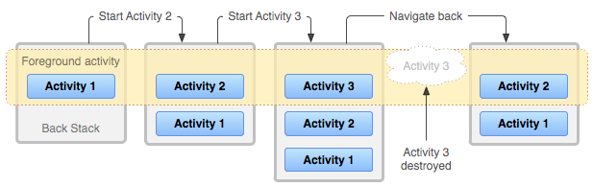

Android provides a back stack for each *task*. A task is an organizing concept for each Activity the user interacts with when performing an operation, whether they are inside your app or across multiple apps. Most tasks start from the Android home screen, and tapping an app icon starts a task (and a new back stack) for that app. If the user uses an app for a while, taps home, and starts a new app, that new app launches in its own task and has its own back stack. If the user returns to the first app, that first task's back stack returns. Navigating with the Back button returns only to the Activity in the current task, not for all tasks running on the device. Android enables the user to navigate between tasks with the overview or recent tasks screen, accessible with the square button on lower right corner of the device  Device task button  .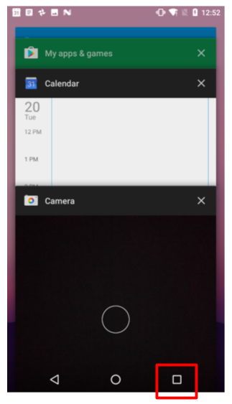

In most cases you don't have to worry about managing either tasks or the back stack for your app—the system keeps track of these things for you, and the back button is always available on the device.

There may, however, be times where you may want to override the default behavior for tasks or for the back stack. For example, if your screen contains an embedded web browser where users can navigate between web pages, you may wish to use the browser's default back behavior when users press the device's *Back* button, rather than returning to the previous Activity. You may also need to change the default behavior for your app in other special cases such as with notifications or widgets, where an Activity deep within your app may be launched as its own task, with no back stack at all. You learn more about managing tasks and the back stack in a later section.

Up navigation

Up navigation, sometimes referred to as ancestral or logical navigation, is used to navigate within an app based on the explicit hierarchical relationships between screens. With Up navigation, each Activity is arranged in a hierarchy, and each "child" Activity shows a left-facing arrow in the app bar  Up button (in app bar)  that returns the user to the "parent" Activity. The topmost Activity in the hierarchy is usually MainActivity, and the user cannot go up from there.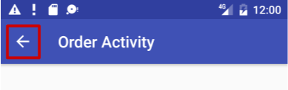

For instance, if the main Activity in an email app is a list of all messages, selecting a message launches a second Activity to display that single email. In this case the message Activity would provide an Up button that returns to the list of messages.

The behavior of the Up button is defined by you in each Activity based on how you design your app's navigation. In many cases, Up and Back navigation may provide the same behavior: to just return to the previous Activity. For example, a Settings Activity may be available from any Activity in your app, so "up" is the same as back—just return the user to their previous place in the hierarchy.

Providing Up behavior for your app is optional, but a good design practice, to provide consistent navigation for your app.

Implement Up navigation with a parent Activity

With the standard template projects in Android Studio, it's straightforward to implement Up navigation. If one Activity is a child of another Activity in your app's Activity hierarchy, specify the parent of that other Activity in the AndroidManifest.xml file.

Beginning in Android 4.1 (API level 16), declare the logical parent of each Activity by specifying the android:parentActivityName attribute in the <activity> element. To support older versions of Android, include <meta-data> information to define the parent Activity explicitly. Use both methods to be backwards-compatible with all versions of Android.

The following are the skeleton definitions in AndroidManifest.xml for both a main (parent) Activity (MainActivity) and a second (child) Activity (SecondActivity):

<application

android:allowBackup="true"

android:icon="@mipmap/ic_launcher"

android:label="@string/app_name"

android:roundIcon="@mipmap/ic_launcher_round"

android:supportsRtl="true"

android:theme="@style/AppTheme">

<!-- The main activity (it has no parent activity) -->

<activity android:name=".MainActivity">

<intent-filter>

<action android:name="android.intent.action.MAIN" />

<category android:name="android.intent.category.LAUNCHER" />

</intent-filter>

</activity>

<!-- The child activity) -->

<activity android:name=".SecondActivity"

android:label = "Second Activity"

android:parentActivityName=".MainActivity">

<meta-data

android:name="android.support.PARENT_ACTIVITY"

android:value="com.example.android.twoactivities.MainActivity" />

</activity>

</application>

You learn more about Up navigation and other user navigation features in another practical.

Related practical

The related practical is [2.1: Activities and intents](https://codelabs.developers.google.com/codelabs/android-training-create-an-activity).

Learn more

Android Studio documentation:

* [Meet Android Studio](https://developer.android.com/studio/intro/index.html)

Android developer documentation:

* [Application Fundamentals](http://developer.android.com/guide/components/fundamentals.html)
* [Activities](http://developer.android.com/guide/components/activities.html)
* [Intents and Intent Filters](http://developer.android.com/guide/components/intents-filters.html)
* [Designing Back and Up navigation](https://developer.android.com/training/design-navigation/ancestral-temporal)
* [Activity](http://developer.android.com/reference/android/app/Activity.html)
* [Intent](http://developer.android.com/reference/android/content/Intent.html)
* [ScrollView](https://developer.android.com/reference/android/widget/ScrollView.html)
* [View](http://developer.android.com/reference/android/view/View.html)

2.2: Activity lifecycle and state

**Contents:**

* [Introduction](https://google-developer-training.github.io/android-developer-fundamentals-course-concepts-v2/unit-1-get-started/lesson-2-activities-and-intents/2-2-c-activity-lifecycle-and-state/2-2-c-activity-lifecycle-and-state.html#chapterstart)
* [About the Activity lifecycle](https://google-developer-training.github.io/android-developer-fundamentals-course-concepts-v2/unit-1-get-started/lesson-2-activities-and-intents/2-2-c-activity-lifecycle-and-state/2-2-c-activity-lifecycle-and-state.html#aboutlifecycle)
* [Activity states and lifecycle callback methods](https://google-developer-training.github.io/android-developer-fundamentals-course-concepts-v2/unit-1-get-started/lesson-2-activities-and-intents/2-2-c-activity-lifecycle-and-state/2-2-c-activity-lifecycle-and-state.html#activitystatesandcallbacks)
* [Configuration changes and Activity state](https://google-developer-training.github.io/android-developer-fundamentals-course-concepts-v2/unit-1-get-started/lesson-2-activities-and-intents/2-2-c-activity-lifecycle-and-state/2-2-c-activity-lifecycle-and-state.html#configurationchanges)
* [Related practical](https://google-developer-training.github.io/android-developer-fundamentals-course-concepts-v2/unit-1-get-started/lesson-2-activities-and-intents/2-2-c-activity-lifecycle-and-state/2-2-c-activity-lifecycle-and-state.html#relatedpractical)
* [Learn more](https://google-developer-training.github.io/android-developer-fundamentals-course-concepts-v2/unit-1-get-started/lesson-2-activities-and-intents/2-2-c-activity-lifecycle-and-state/2-2-c-activity-lifecycle-and-state.html#learnmore)

Introduction

In this chapter you learn about the activity lifecycle, the callback events you can implement to perform tasks in each stage of the lifecycle, and how to handle Activity instance states throughout the activity lifecycle.

About the activity lifecycle

The activity lifecycle is the set of states an activity can be in during its entire lifetime, from the time it's created to when it's destroyed and the system reclaims its resources. As the user interacts with your app and other apps on the device, activities move into different states.

For example:

* When you start an app, the app's main activity ("Activity 1" in the figure below) is started, comes to the foreground, and receives the user focus.
* When you start a second activity ("Activity 2" in the figure below), a new activity is created and started, and the main activity is stopped.
* When you're done with the Activity 2 and navigate back, Activity 1 resumes. Activity 2 stops and is no longer needed.
* If the user doesn't resume Activity 2, the system eventually destroys it.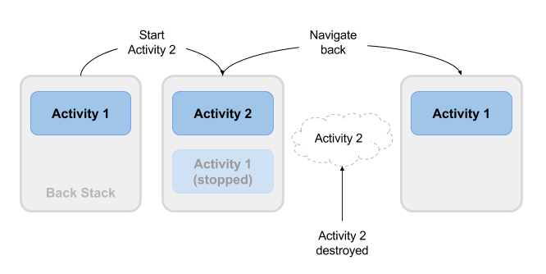

Activity states and lifecycle callback methods

When an Activity transitions into and out of the different lifecycle states as it runs, the Android system calls several lifecycle callback methods at each stage. All of the callback methods are hooks that you can override in each of your Activity classes to define how that Activity behaves when the user leaves and re-enters the Activity. Keep in mind that the lifecycle states (and callbacks) are per Activity, not per app, and you may implement different behavior at different points in the lifecycle of each Activity.

This figure shows each of the Activity states and the callback methods that occur as the Activity transitions between different states: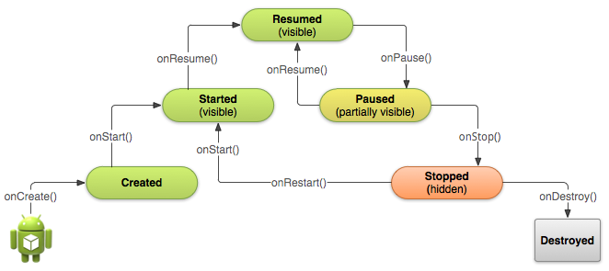

Depending on the complexity of your Activity, you probably don't need to implement all the lifecycle callback methods in an Activity. However, it's important that you understand each one and implement those that ensure your app behaves the way users expect. Managing the lifecycle of an Activity by implementing callback methods is crucial to developing a strong and flexible app.

Activity created: the onCreate() method

@Override

public void onCreate(Bundle savedInstanceState) {

super.onCreate(savedInstanceState);

// The activity is being created.

}

Your Activity enters into the created state when it is started for the first time. When an Activity is first created, the system calls the onCreate() method to initialize that Activity. For example, when the user taps your app icon from the Home screen to start that app, the system calls the onCreate() method for the Activity in your app that you've declared to be the "launcher" or "main" Activity. In this case the main Activity onCreate() method is analogous to the main() method in other programs.

Similarly, if your app starts another Activity with an Intent (either explicit or implicit), the system matches your Intent request with an Activity and calls onCreate() for that new Activity.

The onCreate() method is the only required callback you must implement in your Activity class. In your onCreate() method you perform basic app startup logic that should happen only once, such as setting up the user interface, assigning class-scope variables, or setting up background tasks.

Created is a transient state; the Activity remains in the created state only as long as it takes to run onCreate(), and then the Activity moves to the started state.

Activity started: the onStart() method

@Override

protected void onStart() {

super.onStart();

// The activity is about to become visible.

}

After your Activity is initialized with onCreate(), the system calls the onStart() method, and the Activity is in the started state. The onStart() method is also called if a stopped Activity returns to the foreground, such as when the user clicks the Back button or the Up button to navigate to the previous screen. While onCreate() is called only once when the Activity is created, the onStart() method may be called many times during the lifecycle of the Activity as the user navigates around your app.

When an Activity is in the started state and visible on the screen, the user cannot interact with it until onResume() is called, the Activity is running, and the Activity is in the foreground.

Typically you implement onStart() in your Activity as a counterpart to the onStop() method. For example, if you release hardware resources (such as GPS or sensors) when the Activity is stopped, you can re-register those resources in the onStart() method.

Started, like created, is a transient state. After starting, the Activity moves into the resumed (running) state.

Activity resumed/running: the onResume() method

@Override

protected void onResume() {

super.onResume();

// The activity has become visible (it is now "resumed").

}

Your Activity is in the resumed state when it is initialized, visible on screen, and ready to use. The resumed state is often called the running state, because it is in this state that the user is actually interacting with your app.

The first time the Activity is started the system calls the onResume() method just after onStart(). The onResume() method may also be called multiple times, each time the app comes back from the paused state.

As with the onStart() and onStop() methods, which are implemented in pairs, you typically only implement onResume() as a counterpart to onPause(). For example, if in the onPause() method you halt any animations, you would start those animations again in onResume().

The Activity remains in the resumed state as long as the Activity is in the foreground and the user is interacting with it. From the resumed state the Activity can move into the paused state.

Activity paused: the onPause() method

@Override

protected void onPause() {

super.onPause();

// Another activity is taking focus

// (this activity is about to be "paused").

}

The paused state can occur in several situations:

* The Activity is going into the background, but has not yet been fully stopped. This is the first indication that the user is leaving your Activity.
* The Activity is only partially visible on the screen, because a dialog or other transparent Activity is overlaid on top of it.
* In multi-window or split screen mode (API 24), the Activity is displayed on the screen, but some other Activity has the user focus.

The system calls the onPause() method when the Activity moves into the paused state. Because the onPause() method is the first indication you get that the user may be leaving the Activity, you can use onPause() to stop animation or video playback, release any hardware-intensive resources, or commit unsaved Activity changes (such as a draft email).

The onPause() method should execute quickly. Don't use onPause() for CPU-intensive operations such as writing persistent data to a database. The app may still be visible on screen as it passes through the paused state, and any delays in executing onPause() can slow the user's transition to the next Activity. Implement any heavy-load operations when the app is in the stopped state instead.

Note that in multi-window mode (API 24), your paused Activity may still fully visible on the screen. In this case you do not want to pause animations or video playback as you would for a partially visible Activity. You can use the inMultiWindowMode() method in the Activity class to test whether your app is running in multi-window mode.

Your Activity can move from the paused state into the resumed state (if the user returns to the Activity) or to the stopped state (if the user leaves the Activity altogether).

Activity stopped: the onStop() method

@Override

protected void onStop() {

super.onStop();

// The activity is no longer visible (it is now "stopped")

}

An Activity is in the stopped state when it's no longer visible on the screen. This is usually because the user started another activity or returned to the home screen. The Android system retains the activity instance in the back stack, and if the user returns to the activity, the system restarts it. If resources are low, the system might kill a stopped activity altogether.

The system calls the onStop() method when the activity stops. Implement the onStop() method to save persistent data and release resources that you didn't already release in onPause(), including operations that may have been too heavyweight for onPause().

Activity destroyed: the onDestroy() method

@Override

protected void onDestroy() {

super.onDestroy();

// The activity is about to be destroyed.

}

When your Activity is destroyed it is shut down completely, and the Activity instance is reclaimed by the system. This can happen in several cases:

* You call finish() in your Activity to manually shut it down.
* The user navigates back to the previous Activity.
* The device is in a low memory situation where the system reclaims any stopped Activity to free more resources.
* A device configuration change occurs. You learn more about configuration changes later in this chapter.

Use onDestroy() to fully clean up after your Activity so that no component (such as a thread) is running after the Activity is destroyed.

Note that there are situations where the system will simply kill the hosting process for the Activity without calling this method (or any others), so you should not rely on onDestroy() to save any required data or Activity state. Use onPause() or onStop() instead.

Activity restarted: the onRestart() method

@Override

protected void onRestart() {

super.onRestart();

// The activity is about to be restarted.

}

The restarted state is a transient state that only occurs if a stopped Activity is started again. In this case the onRestart() method is called between onStop() and onStart(). If you have resources that need to be stopped or started you typically implement that behavior in onStop() or onStart() rather than onRestart().

Configuration changes and Activity state

Earlier in the section on onDestroy() you learned that your Activity may be destroyed when the user navigates back, or when your code executes the finish() method, or when the system needs to free resources. Another way an Activity can be destroyed is when the device undergoes a *configuration change*.

Configuration changes occur on the device, in runtime, and invalidate the current layout or other resources in your Activity. The most common form of a configuration change is when the device is rotated. When the device rotates from portrait to landscape, or from landscape to portrait, the layout for your app needs to change. The system recreates the Activity to help that Activity adapt to the new configuration by loading alternative resources (such as a landscape-specific layout).

Other configuration changes can include a change in locale (the user chooses a different system language), or the user enters multi-window mode (Android 7). In multi-window mode, if you have configured your app to be resizeable, Android recreates the Activity to use a layout definition for the new, smaller size.

When a configuration change occurs, the Android system shuts down your activity, calling onPause(), onStop(), and onDestroy(). Then the system restarts the activity from the beginning, calling onCreate(), onStart(), and onResume().

Activity instance state

When an Activity is destroyed and recreated, there are implications for the runtime state of that Activity. When an Activity is paused or stopped, the state of the Activity is retained because that Activity is still held in memory. When an Activity is recreated, the state of the Activity and any user progress in that Activity is lost, with these exceptions:

* Some Activity state information is automatically saved by default. The state of View elements in your layout with a unique ID (as defined by the android:id attribute in the layout) are saved and restored when an Activity is recreated. In this case, the user-entered values in EditText elements are usually retained when the Activity is recreated.
* The Intent that was used to start the Activity, and the information stored in the data or extras for that Intent, remains available to that Activity when it is recreated.

The Activity state is stored as a set of key/value pairs in a [Bundle](https://developer.android.com/reference/android/os/Bundle.html) object called the Activity *instance state* . The system saves default state information to instance state Bundle just before the Activity is stopped, and passes that Bundle to the new Activity instance to restore.

You can add your own instance data to the instance state Bundle by overriding the onSaveInstanceState() callback. The state Bundle is passed to the onCreate() method, so you can restore that instance state data when your Activity is created. There is also a corresponding onRestoreInstanceState() callback you can use to restore the state data.

Test that your Activity behaves correctly when the user rotates the device, because device rotation is a common use case. Implement instance state if you need to.

**Note:**The Activity instance state is particular to a specific instance of an Activity, running in a single task. If the user force-quits the app or reboots the device, or if the Android system shuts down the app process to preserve memory, the Activity instance state is lost. To keep state changes across app instances and device reboots, you need to write that data to shared preferences. You learn more about shared preferences in another chapter.

Saving Activity instance state

To save information to the instance state Bundle, use the onSaveInstanceState() callback. This is not a lifecycle callback method, but it is called when the user is leaving your Activity (sometime before the onStop() method).

@Override

public void onSaveInstanceState(Bundle savedInstanceState) {

super.onSaveInstanceState(savedInstanceState);

// save your state data to the instance state bundle

}

The onSaveInstanceState() method is passed a Bundle object (a collection of key/value pairs) when it is called. This is the instance state Bundle to which you will add your own Activity state information.

You learned about [Bundle](https://developer.android.com/reference/android/os/Bundle.html) in a previous chapter when you added keys and values to the Intent extras. Add information to the instance state Bundle in the same way, with keys you define and the various "put" methods defined in the Bundle class:

@Override

public void onSaveInstanceState(Bundle savedInstanceState) {

super.onSaveInstanceState(savedInstanceState);

// Save the user's current game state

savedInstanceState.putInt("score", mCurrentScore);

savedInstanceState.putInt("level", mCurrentLevel);

}

Don't forget to call through to the superclass, to make sure the state of the View hierarchy is also saved to the Bundle.

Restoring Activity instance state

Once you've saved the Activity instance state, you also need to restore it when the Activity is recreated. You can do this one of two places:

* The onCreate() callback method, which is called with the instance state Bundle when the Activity is created.
* The onRestoreInstanceState() callback, which is called after onStart() after the Activity is created.

Most of the time the better place to restore the Activity state is in onCreate(), to ensure that your UI, including the state, is available as soon as possible.

To restore the saved instances state in onCreate(), test for the existence of a state Bundle before you try to get data out of it. When your Activity is started for the first time there will be no state and the Bundle will be null.

@Override

protected void onCreate(Bundle savedInstanceState) {

// Always call the superclass first

super.onCreate(savedInstanceState);

// Check if recreating a previously destroyed instance.

if (savedInstanceState != null) {

// Restore value of members from saved state.

mCurrentScore = savedInstanceState.getInt("score");

mCurrentLevel = savedInstanceState.getInt("level");

} else {

// Initialize members with default values for a new instance.

// ...

}

// ... Rest of code

}

Related practical

The related practical is [2.2: Activity lifecycle and state](https://codelabs.developers.google.com/codelabs/android-training-activity-lifecycle-and-state).

Learn more

Android Studio documentation:

* [Meet Android Studio](https://developer.android.com/studio/intro/index.html)

Android developer documentation:

* [Application Fundamentals](http://developer.android.com/guide/components/fundamentals.html)
* [Activities](http://developer.android.com/guide/components/activities.html)
* [Understand the Activity Lifecycle](https://developer.android.com/guide/components/activities/activity-lifecycle)
* [Intents and Intent Filters](http://developer.android.com/guide/components/intents-filters.html)
* [Handle configuration changes](http://developer.android.com/guide/topics/resources/runtime-changes.html)
* [Activity](http://developer.android.com/reference/android/app/Activity.html)
* [Intent](http://developer.android.com/reference/android/content/Intent.html)
* [Bundle](https://developer.android.com/reference/android/os/Bundle.html)

2.3: Implicit intents

**Contents:**

* [Introduction](https://google-developer-training.github.io/android-developer-fundamentals-course-concepts-v2/unit-1-get-started/lesson-2-activities-and-intents/2-3-c-implicit-intents/2-3-c-implicit-intents.html#chapterstart)
* [Understanding an implicit Intent](https://google-developer-training.github.io/android-developer-fundamentals-course-concepts-v2/unit-1-get-started/lesson-2-activities-and-intents/2-3-c-implicit-intents/2-3-c-implicit-intents.html#aboutimplicitintents)
* [Sending an implicit Intent](https://google-developer-training.github.io/android-developer-fundamentals-course-concepts-v2/unit-1-get-started/lesson-2-activities-and-intents/2-3-c-implicit-intents/2-3-c-implicit-intents.html#sendingimplicitintents)
* [Receiving an implicit Intent](https://google-developer-training.github.io/android-developer-fundamentals-course-concepts-v2/unit-1-get-started/lesson-2-activities-and-intents/2-3-c-implicit-intents/2-3-c-implicit-intents.html#receivingimplicitintents)
* [Sharing data with ShareCompat.IntentBuilder](https://google-developer-training.github.io/android-developer-fundamentals-course-concepts-v2/unit-1-get-started/lesson-2-activities-and-intents/2-3-c-implicit-intents/2-3-c-implicit-intents.html#sharingdatawithsharecompat)
* [Managing tasks](https://google-developer-training.github.io/android-developer-fundamentals-course-concepts-v2/unit-1-get-started/lesson-2-activities-and-intents/2-3-c-implicit-intents/2-3-c-implicit-intents.html#managingtasksandactivities)
* [Activity launch modes](https://google-developer-training.github.io/android-developer-fundamentals-course-concepts-v2/unit-1-get-started/lesson-2-activities-and-intents/2-3-c-implicit-intents/2-3-c-implicit-intents.html#activitylaunchmodes)
* [Task affinities](https://google-developer-training.github.io/android-developer-fundamentals-course-concepts-v2/unit-1-get-started/lesson-2-activities-and-intents/2-3-c-implicit-intents/2-3-c-implicit-intents.html#taskaffinities)
* [Related practical](https://google-developer-training.github.io/android-developer-fundamentals-course-concepts-v2/unit-1-get-started/lesson-2-activities-and-intents/2-3-c-implicit-intents/2-3-c-implicit-intents.html#relatedpractical)
* [Learn more](https://google-developer-training.github.io/android-developer-fundamentals-course-concepts-v2/unit-1-get-started/lesson-2-activities-and-intents/2-3-c-implicit-intents/2-3-c-implicit-intents.html#learnmore)

Introduction

In a previous chapter you learned how to launch a specific activity in your app with an explicit intent. In this chapter you learn how to send and receive an *implicit* intent. In an implicit intent, you declare a general action to perform, and the system matches your request with an activity.

You also learn more about Android *tasks*, and how you can configure your apps to associate new activities with different tasks.

Understanding an implicit Intent

In an earlier chapter you learned how to start an activity from an activity by specifying the class name of the activity to start in an *explic*it intent. This is the most basic way to use an intent: To start an [Intent](http://developer.android.com/reference/android/content/Intent.html) or other app component and pass data to it (and sometimes receive data).

A more flexible use of an [Intent](http://developer.android.com/reference/android/content/Intent.html) is the *implicit* intent. You don't specify the exact activity (or other component) to run—instead, you include just enough information in the intent about the task you want to perform. The Android system matches the information in your request intent with any activity available on the device that can perform that task. If there's only one activity that matches, that activity is launched. If more than one activity matches the intent, the user is presented with an app chooser and picks which app they would like to perform the task.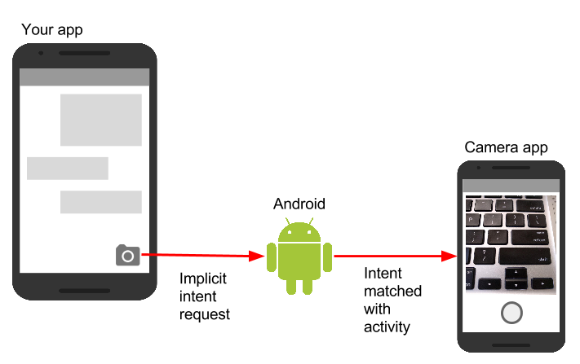

For example, you have an app that lists available snippets of video. If the user touches an item in the list, you want to play that video snippet. Rather than implementing an entire video player in your own app, you can launch an Intent that specifies the task as "play an object of type video." The Android system then matches your request with an Activity that has registered itself to play objects of type video.

An Activity registers itself with the system as being able to handle an implicit Intent with Intent *filters*, declared in the AndroidManifest.xml file. For example, the main Activity (and only the main Activity) for your app has an Intent filter that declares it the main Activity for the launcher category. This Intent filter is how the Android system knows to start that specific Activity in your app when the user taps the icon for your app on the device home screen.

Intent actions, categories, and data

An implicit Intent, like an explicit Intent, is an instance of the [Intent](http://developer.android.com/reference/android/content/Intent.html) class. In addition to the parts of an Intent you learned about in an earlier chapter (such as the Intent data and extras), these fields are used by an implicit Intent:

* The Intent *action*, which is the generic action the receiving Activity should perform. The available Intent actions are defined as constants in the [Intent](http://developer.android.com/reference/android/content/Intent.html) class and begin with the word ACTION_. A common Intent action is ACTION_VIEW, which you use when you have some information that an Activity can show to the user, such as a photo to view in a gallery app, or an address to view in a map app. You can specify the action for an Intent in the Intent constructor, or with the setAction() method.
* An Intent *category*, which provides additional information about the category of component that should handle the Intent. Intent categories are optional, and you can add more than one category to an Intent. Intent categories are also defined as constants in the Intent class and begin with the word CATEGORY_. You can add categories to the Intent with the addCategory() method.
* The data *type*, which indicates the MIME type of data the Activity should operate on. Usually, the data type is inferred from the URI in the Intent data field, but you can also explicitly define the data type with the setType() method.

Intent actions, categories, and data types are used both by the Intent object you create in your sending Activity, as well as in the Intent filters you define in the AndroidManifest.xml file for the receiving Activity. The Android system uses this information to match an implicit Intent request with an Activity or other component that can handle that Intent.

Sending an implicit Intent

Starting an Activity with an implicit Intent, and passing data from one Activity to another, works much the same way as it does for an explicit Intent:

1. In the sending Activity, create a new Intent object.
2. Add information about the request to the Intent object, such as data or extras.
3. Send the Intent with startActivity() (to just start the Activity) or startActivityforResult() (to start the Activity and expect a result back).

When you create an implicit Intent object, you:

* Do *not* specify the specific Activity or other component to launch.
* Add an Intent action or Intent categories (or both).
* Resolve the Intent with the system before calling startActivity() or startActivityforResult().
* Show an app chooser for the request (optional).

Create implicit Intent objects

To use an implicit Intent, create an Intent object as you did for an explicit Intent, only without the specific component name.

Intent sendIntent = new Intent();

You can also create the Intent object with a specific action:

Intent sendIntent = new Intent(Intent.ACTION_VIEW);

Once you have an Intent object you can add other information (category, data, extras) with the various Intent methods. For example, this code creates an implicit Intent object, sets the Intent action to ACTION_SEND, defines an Intent extra to hold the text, and sets the type of the data to the MIME type "text/plain".

Intent sendIntent = new Intent();

sendIntent.setAction(Intent.ACTION_SEND);

sendIntent.putExtra(Intent.EXTRA_TEXT, textMessage);

sendIntent.setType("text/plain");

Resolve the Activity before starting it

When you define an implicit Intent with a specific action and/or category, there is a possibility that there won't be *any*Activity on the device that can handle your request. If you just send the Intent and there is no appropriate match, your app will crash.

To verify that an Activity or other component is available to receive your Intent, use the resolveActivity() method with the system package manager like this:

if (sendIntent.resolveActivity(getPackageManager()) != null) {

startActivity(chooser);

}

If the result of resolveActivity() is not null, then there is at least one app available that can handle the Intent, and it's safe to call startActivity(). Do not send the Intent if the result is null.

If you have a feature that depends on an external Activity that may or may not be available on the device, a best practice is to test for the availability of that external Activity before the user tries to use it. If there is no Activity that can handle your request (that is, resolveActivity() returns null), disable the feature or provide the user an error message for that feature.

Show the app chooser

To find an Activity or other component that can handle your Intent requests, the Android system matches your implicit Intent with an Activity whose Intent filters indicate that they can perform that action. If there are multiple apps installed that match, the user is presented with an app chooser that lets them select which app they want to use to handle that Intent.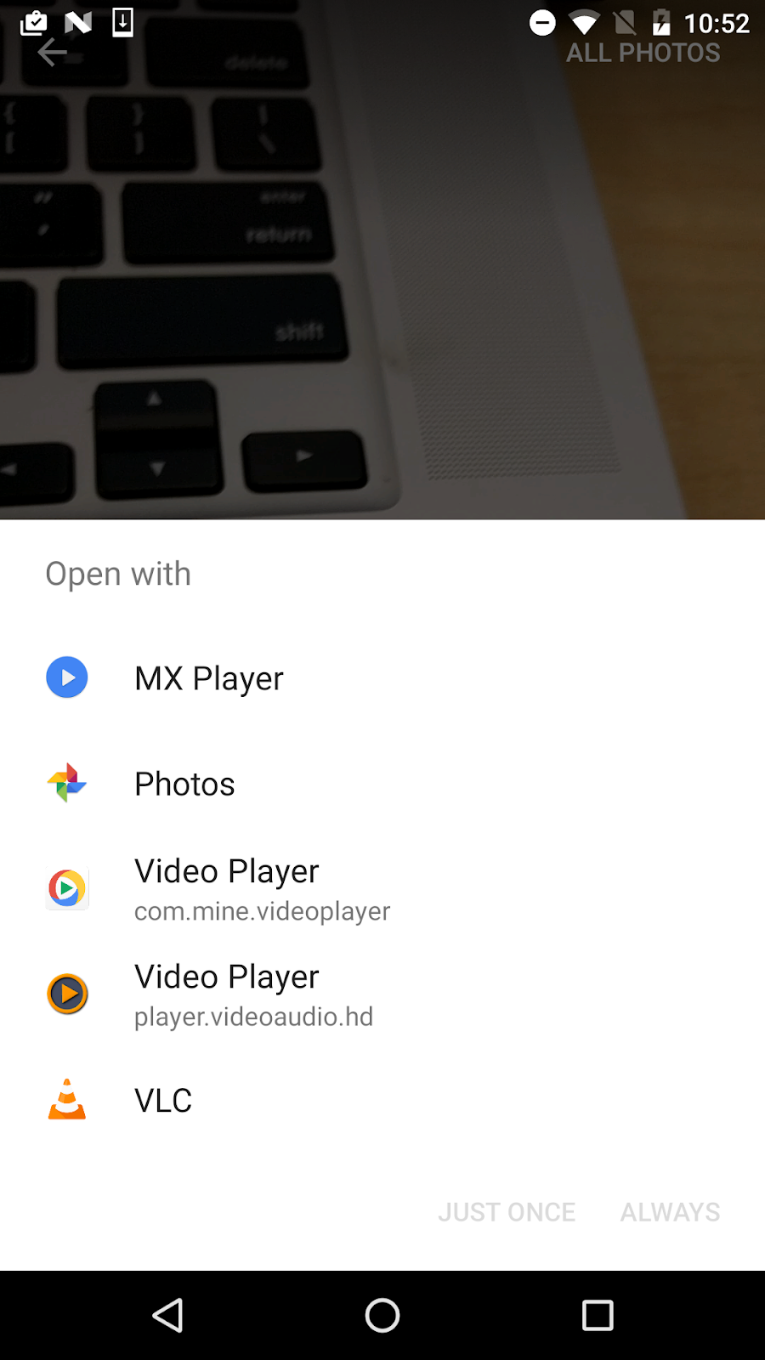

In many cases the user has a preferred app for a given task, and they will select the option to always use that app for that task. However, if multiple apps can respond to the Intent and the user might want to use a different app each time, you can choose to explicitly show a chooser dialog every time. For example, when your app performs a "share this" action with the [ACTION_SEND](https://developer.android.com/reference/android/content/Intent.html#ACTION_SEND) action, users may want to share using a different app depending on the current situation.

To show the chooser, you create a wrapper Intent for your implicit Intent with the createChooser() method, and then resolve and call startActivity() with that wrapper Intent. The createChooser() method also requires a string argument for the title that appears on the chooser. You can specify the title with a string resource as you would any other string.

For example:

// The implicit Intent object

Intent sendIntent = new Intent(Intent.ACTION_SEND);

// Always use string resources for UI text.

String title = getResources().getString(R.string.chooser_title);

// Create the wrapper intent to show the chooser dialog.

Intent chooser = Intent.createChooser(sendIntent, title);

// Resolve the intent before starting the activity

if (sendIntent.resolveActivity(getPackageManager()) != null) {

startActivity(chooser);

}

Receiving an implicit Intent

If you want an Activity in your app to respond to an implicit Intent (from your own app or other apps), declare one or more Intent filters in the AndroidManifest.xml file. Each Intent filter specifies the type of Intent it accepts based on the action, data, and category for the Intent. The system will deliver an implicit Intent to your app component only if that Intent can pass through one of your Intent filters.

**Note:**An explicit Intent is always delivered to its target, regardless of any Intent filters the component declares. Conversely, if an Activity does not include Intent filters, it can only be launched with an explicit Intent.

Once your Activity is successfully launched with an implicit Intent, you can handle that Intent and its data the same way you did an explicit Intent, by:

1. Getting the Intent object with getIntent().
2. Getting Intent data or extras out of that Intent.
3. Performing the task the Intent requested.
4. Returning data to the calling Activity with another Intent, if needed.

Intent filters

Define Intent filters with one or more <intent-filter> elements in the AndroidManifest.xml file, nested in the corresponding <activity> element. Inside <intent-filter>, specify the type of intent your activity can handle. The Android system matches an implicit intent with an activity or other app component only if the fields in the Intent object match the Intent filters for that component.

An Intent filter may contain the following elements, which correspond to the fields in the Intent object described above:

* <action>: The Intent action that the activity accepts.
* <data>: The type of data accepted, including the MIME type or other attributes of the data URI (such as scheme, host, port, and path).
* <category>: The Intent category.

For example, the main Activity for your app includes this <intent-filter> element, which you saw in an earlier chapter:

<intent-filter>

<action android:name="android.intent.action.MAIN" />

<category android:name="android.intent.category.LAUNCHER" />

</intent-filter>

This Intent filter has the action MAIN and the category LAUNCHER. The <action> element specifies that this is the app's "main" entry point. The <category> element specifies that this activity should be listed in the system's app launcher (to allow users to launch the activity). Only the main activity for your app should have this Intent filter.

Here's another example for an implicit Intent that shares a bit of text. This Intent filter matches the implicit Intent example from the previous section:

<activity android:name="ShareActivity">

<intent-filter>

<action android:name="android.intent.action.SEND"/>

<category android:name="android.intent.category.DEFAULT"/>

<data android:mimeType="text/plain"/>

</intent-filter>

</activity>

You can specify more than one action, data, or category for the same Intent filter, or have multiple Intent filters per Activity to handle each different kind of Intent.

The Android system tests an implicit Intent against an Intent filter by comparing the parts of that Intent to each of the three Intent filter elements (action, category, and data). The Intent must pass all three tests or the Android system won't deliver the Intent to the component. However, because a component may have multiple Intent filters, an Intent that does not pass through one of a component's filters might make it through on another filter.

Actions

An Intent filter can declare zero or more <action> elements for the Intent action. The action is defined in the name attribute, and consists of the string "android.intent.action." plus the name of the Intent action, minus the ACTION_ prefix. So, for example, an implicit Intent with the action ACTION_VIEW matches an Intent filter whose action is android.intent.action.VIEW.

For example, this Intent filter matches either ACTION_EDIT and ACTION_VIEW:

<intent-filter>

<action android:name="android.intent.action.EDIT" />

<action android:name="android.intent.action.VIEW" />

</intent-filter>

To get through this filter, the action specified in the incoming Intent object must match at least one of the actions. You must include at least one Intent action for an incoming implicit Intent to match.

Categories

An Intent filter can declare zero or more <category> elements for Intent categories. The category is defined in the name attribute, and consists of the string "android.intent.category." plus the name of the Intent category, minus the CATEGORY prefix.

For example, this Intent filter matches either CATEGORY_DEFAULT and CATEGORY_BROWSABLE:

<intent-filter>

<category android:name="android.intent.category.DEFAULT" />

<category android:name="android.intent.category.BROWSABLE" />

</intent-filter>

Note that any Activity that you want to accept an implicit Intent must include the android.intent.category.DEFAULT Intent filter. This category is applied to all implicit Intent objects by the Android system.

Data

An Intent filter can declare zero or more <data> elements for the URI contained in the Intent data. As the Intent data consists of a URI and (optionally) a MIME type, you can create an Intent filter for various aspects of that data, including:

* URI Scheme
* URI Host
* URI Path
* Mime type

For example, this Intent filter matches any data Intent with a URI scheme of http and a MIME type of either "video/mpeg" or "audio/mpeg".

<intent-filter>

<data android:mimeType="video/mpeg" android:scheme="http" />

<data android:mimeType="audio/mpeg" android:scheme="http" />

</intent-filter>

Sharing data using ShareCompat.IntentBuilder

Share actions are an easy way for users to share items in your app with social networks and other apps. Although you can build a share action in your own app using an implicit Intent with the ACTION_SEND action, Android provides the [ShareCompat.IntentBuilder](http://developer.android.com/reference/android/support/v4/app/ShareCompat.IntentBuilder.html) helper class to easily implement sharing in your app.

**Note:**For apps that target Android releases after API 14, you can use the ShareActionProvider class for share actions instead of ShareCompat.IntentBuilder. The ShareCompat class is part of the V4 support library, and allows you to provide share actions in apps in a backward-compatible fashion. ShareCompat provides a single API for sharing on both old and new Android devices. You learn more about the Android support libraries in another chapter.

With the ShareCompat.IntentBuilder class you do not need to create or send an implicit Intent for the share action. Use the methods in [ShareCompat.IntentBuilder](http://developer.android.com/reference/android/support/v4/app/ShareCompat.IntentBuilder.html) to indicate the data you want to share as well as any additional information. Start with the from() method to create a new Intent builder, add other methods to add more data, and end with the startChooser() method to create and send the Intent. You can chain the methods together like this:

ShareCompat.IntentBuilder

.from(this) // information about the calling activity

.setType(mimeType) // mime type for the data

.setChooserTitle("Share this text with: ") //title for the app chooser

.setText(txt) // intent data

.startChooser(); // send the intent

Managing tasks

In a previous chapter you learned about tasks and the back stack. The task for your app contains its own stack that contains each Activity the user has visited while using your app. As the user navigates around your app, Activity instances for that task are pushed and popped from the stack for that task.

Most of the time the user's navigation from one Activity to another Activity and back again through the stack is straightforward. Depending on the design and navigation of your app there may be complications, especially with an Activity started from another app and other tasks.

For example, say you have an app with three Activity objects: A, B, and C. A launches B with an Intent, and B launches C. C, in turn sends an Intent to launch A. In this case the system creates a *second instance* of A on the top of the stack, rather than bringing the already-running instance to the foreground. Depending on how you implement each Activity, the two instances of A can get out of sync and provide a confusing experience for a user navigating back through the stack.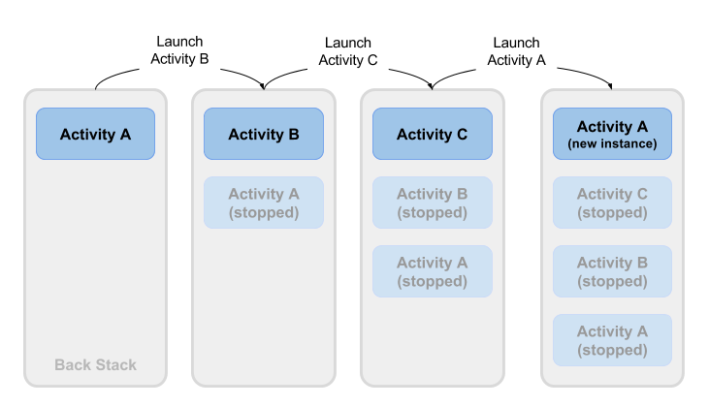

Or, say your Activity C can be launched from a second app with an implicit Intent. The user runs the second app, which has its own task and its own back stack. If that app uses an implicit Intent to launch your Activity C, a new instance of C is created and placed on the back stack for that second app's task. Your app still has its own task, its own back stack, and its own instance of C.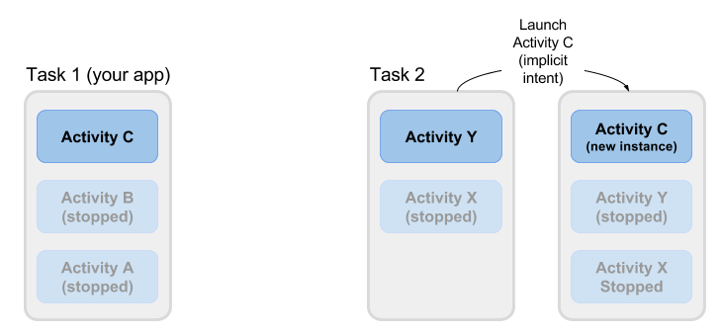

Much of the time the Android's default behavior for tasks works fine and you don't have to worry about how each Activity is associated with tasks, or how they exist in the back stack. If you want to change the normal behavior, Android provides a number of ways to manage tasks and each Activity within those tasks, including:

* Activity launch modes, to determine how an Activity should be launched.
* Task affinities, which indicate which task a launched Activity belongs to.

Activity launch modes

Use Activity launch modes to indicate how each new Activity should be treated when launched—that is, if the Activity should be added to the current task, or launched into a new task. Define launch modes for the Activity with attributes on the <activity> element of the AndroidManifest.xml file, or with flags set on the Intent that starts that Activity.

Activity attributes

To define a launch mode for an Activity add the android:launchMode attribute to the <activity> element in the AndroidManifest.xml file. This example uses a launch mode of "standard", which is the default.

<activity

android:name=".SecondActivity"

android:label="@string/activity2_name"

android:parentActivityName=".MainActivity"

android:launchMode="standard">

<!-- More attributes ... -->

</activity>

There are four launch modes available as part of the <activity> element:

* "standard" (the default): A new Activity is launched and added to the back stack for the current task. An Activity can be instantiated multiple times, a single task can have multiple instances of the same Activity, and multiple instances can belong to different tasks.
* "singleTop": If an instance of an Activity exists at the top of the back stack for the current task and an Intent request for that Activity arrives, Android routes that Intent to the existing Activity instance rather than creating a new instance. A new Activity is still instantiated if there is an existing Activity anywhere in the back stack other than the top.
* "singleTask": When the Activity is launched the system creates a new task for that Activity. If another task already exists with an instance of that Activity, the system routes the Intent to that Activity instead.
* "singleInstance": Same as single task, except that the system doesn't launch any other Activity into the task holding the Activity instance. The Activity is always the single and only member of its task.

The vast majority of apps will only use the standard or single top launch modes. See the [android:launchMode](https://developer.android.com/guide/topics/manifest/activity-element.html#lmode) attribute for more detailed information on launch modes.

Intent flags

Intent flags are options that specify how the activity (or other app component) that receives the intent should handle that intent. Intent flags are defined as constants in the Intent class and begin with the word FLAG_. You add Intent flags to an Intent object with setFlag() or addFlag().

Three specific Intent flags are used to control activity launch modes, either in conjunction with the launchMode attribute or in place of it. Intent flags always take precedence over the launch mode in case of conflicts.

* [FLAG_ACTIVITY_NEW_TASK](https://developer.android.com/reference/android/content/Intent.html#FLAG_ACTIVITY_NEW_TASK): start the Activity in a new task. This behavior is the same as for singleTask launch mode.
* [FLAG_ACTIVITY_SINGLE_TOP](https://developer.android.com/reference/android/content/Intent.html#FLAG_ACTIVITY_SINGLE_TOP): if the Activity to be launched is at the top of the back stack, route the Intent to that existing Activity instance. Otherwise create a new Activity instance. This is the same behavior as the singleTop launch mode.
* [FLAG_ACTIVITY_CLEAR_TOP](https://developer.android.com/reference/android/content/Intent.html#FLAG_ACTIVITY_CLEAR_TOP): If an instance of the Activity to be launched already exists in the back stack, destroy any other Activity on top of it and route the Intent to that existing instance. When used in conjunction with FLAG_ACTIVITY_NEW_TASK, this flag locates any existing instances of the Activity in any task and brings it to the foreground.

See the [Intent](https://developer.android.com/reference/android/content/Intent.html) class for more information about other available Intent flags.

Handle a new Intent

When the Android system routes an Intent to an existing Activity instance, the system calls the onNewIntent() callback method (usually just before the onResume() method). The onNewIntent() method includes an argument for the new Intent that was routed to the Activity. Override the onNewIntent() method in your class to handle the information from that new Intent.

Note that the getIntent() method—to get access to the Intent that launched the Activity—*always* retains the original Intent that launched the Activity instance. Call setIntent() in the onNewIntent() method:

@Override

public void onNewIntent(Intent intent) {

super.onNewIntent(intent);

// Use the new intent, not the original one

setIntent(intent);

}

Any call to getIntent() after this returns the new Intent.

Task affinities

Task affinities indicate which task an Activity prefers to belong to when that Activity instance is launched. By default each Activity belongs to the app that launched it. An Activity from outside an app launched with an implicit Intent belongs to the app that sent the implicit Intent.

To define a task affinity, add the android:taskAffinity attribute to the <activity> element in the AndroidManifest.xml file. The default task affinity is the package name for the app (declared in <manifest>). The new task name should be unique and different from the package name. This example uses "com.example.android.myapp.newtask" for the affinity name.

<activity

android:name=".SecondActivity"

android:label="@string/activity2_name"

android:parentActivityName=".MainActivity"

android:taskAffinity="com.example.android.myapp.newtask">

<!-- More attributes ... -->

</activity>

Task affinities are often used with the singleTask launch mode or the [FLAG_ACTIVITY_NEW_TASK](https://developer.android.com/reference/android/content/Intent.html#FLAG_ACTIVITY_NEW_TASK) Intent flag to place a new Activity in its own named task. If the new task already exists, the Intent is routed to that task and that affinity.

Another use of task affinities is reparenting, which enables a task to move from the Activity in which it was launched to the Activity it has an affinity for. To enable task reparenting, add a task affinity attribute to the <activity> element and set android:allowTaskReparenting to true.

<activity

android:name=".SecondActivity"

android:label="@string/activity2_name"

android:parentActivityName=".MainActivity"

android:taskAffinity="com.example.android.myapp.newtask"

android:allowTaskReparenting="true" >

<!-- More attributes ... -->

</activity>

Related practical

The related practical is [2.3: Implicit intents](https://codelabs.developers.google.com/codelabs/android-training-activity-with-implicit-intent).

Learn more

Android Studio documentation:

* [Meet Android Studio](https://developer.android.com/studio/intro/index.html)

Android developer documentation:

* [Application Fundamentals](http://developer.android.com/guide/components/fundamentals.html)
* [Activities](http://developer.android.com/guide/components/activities.html)
* [Understand the Activity Lifecycle](https://developer.android.com/guide/components/activities/activity-lifecycle)
* [Intents and Intent Filters](http://developer.android.com/guide/components/intents-filters.html)
* [Handle configuration changes](http://developer.android.com/guide/topics/resources/runtime-changes.html)
* [Allowing Other Apps to Start Your Activity](https://developer.android.com/training/basics/intents/filters.html)
* [Understand Tasks and Back Stack](https://developer.android.com/guide/components/activities/tasks-and-back-stack)
* [Activity](http://developer.android.com/reference/android/app/Activity.html)
* [Intent](http://developer.android.com/reference/android/content/Intent.html)
* [<intent-filter>](https://developer.android.com/guide/topics/manifest/intent-filter-element.html)
* [<activity>](https://developer.android.com/guide/topics/manifest/activity-element.html)
* [Uri](http://developer.android.com/reference/android/net/Uri.html)
* [ShareCompat.IntentBuilder](http://developer.android.com/reference/android/support/v4/app/ShareCompat.IntentBuilder.html)

Other:

* [Manipulating Android tasks and back stack](http://www.slideshare.net/RanNachmany/manipulating-android-tasks-and-back-stack)
* Stack Overflow: [Android Task Affinity Explanation](http://stackoverflow.com/questions/17872989/android-task-affinity-explanation)
* The Cheese Factory: [Understand Android Activity's launchMode](https://inthecheesefactory.com/blog/understand-android-activity-launchmode/en)